CAC (Customer Acquisition Cost) - How much money did the company spend to acquire 1 customer?

QUERY:

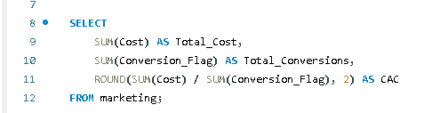

Output :

